Kubernetes minikube

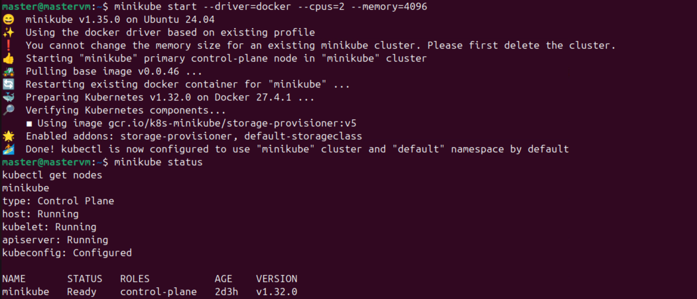

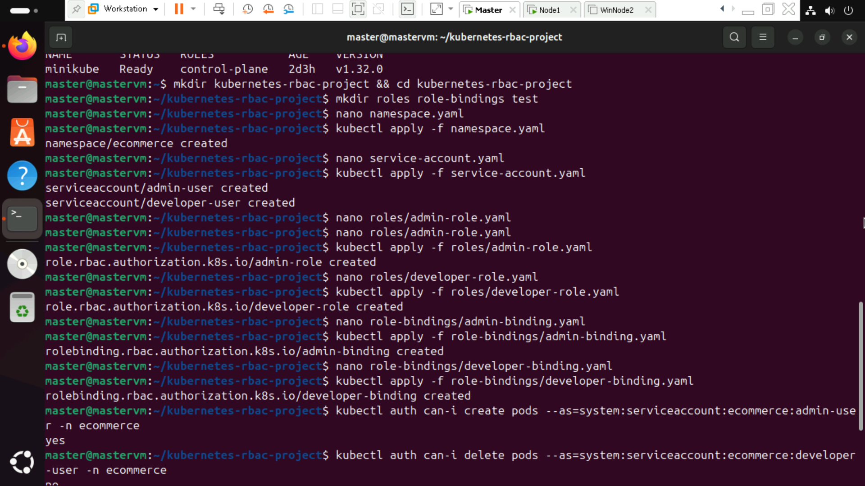

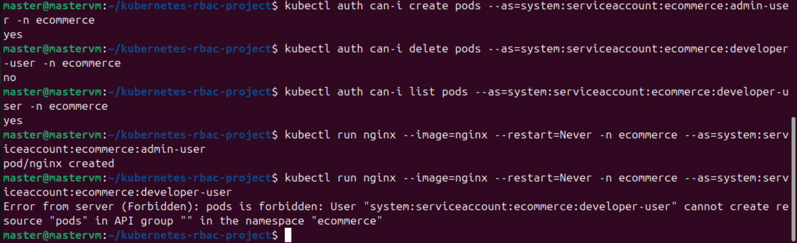

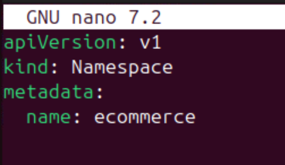

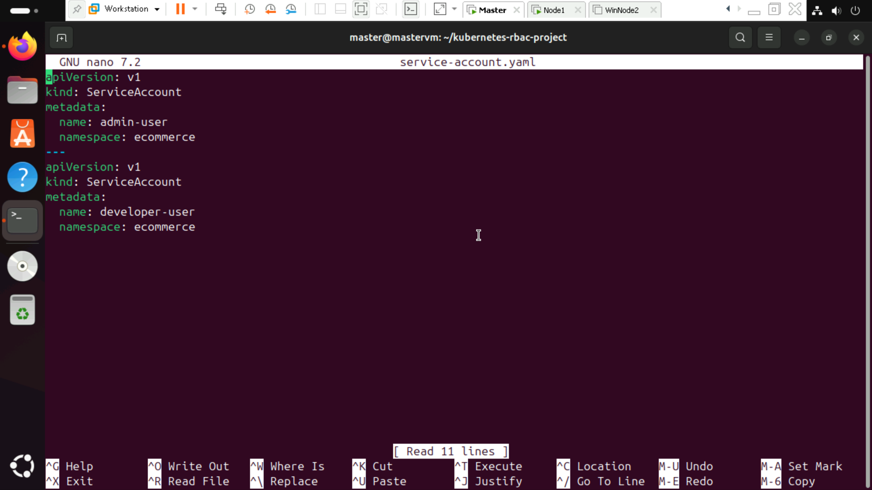

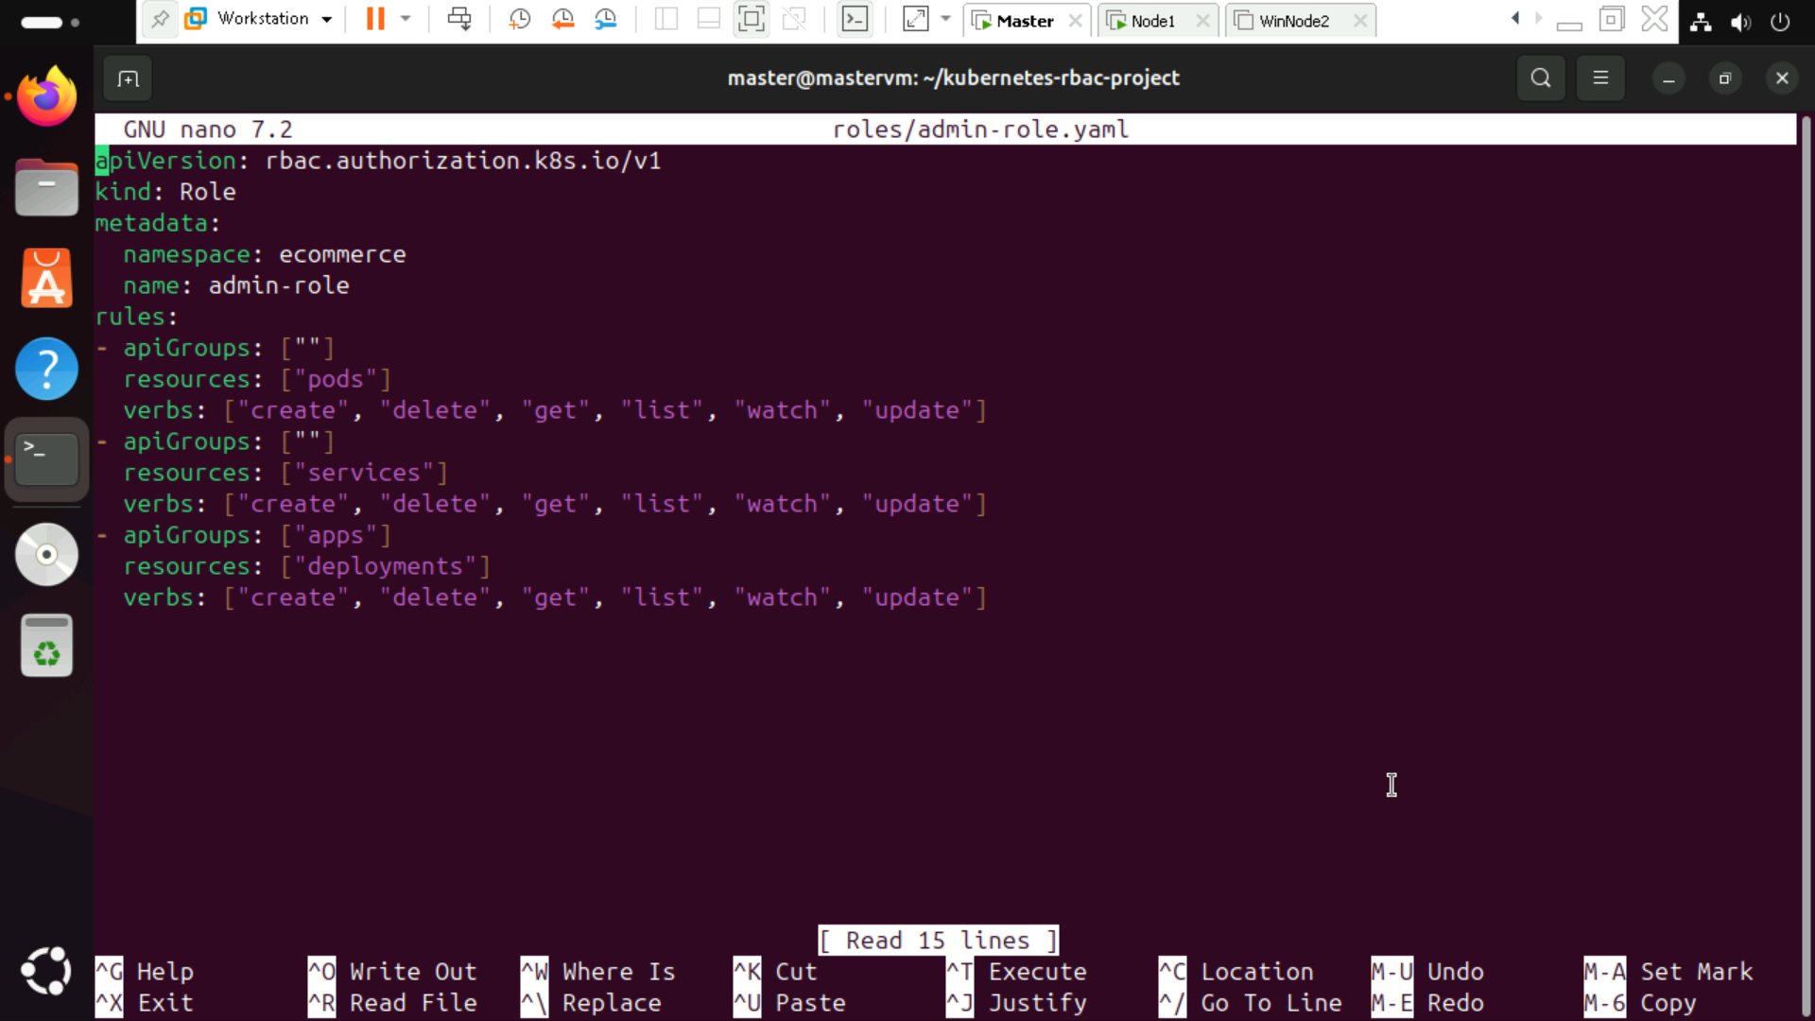

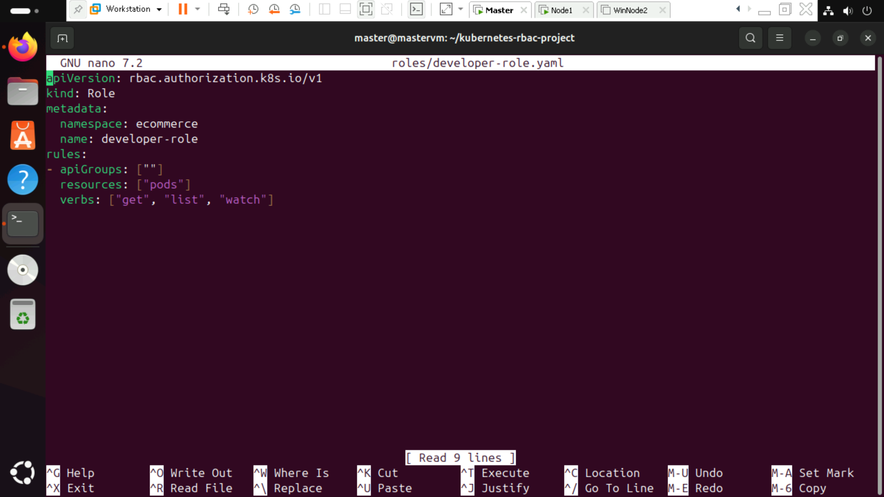

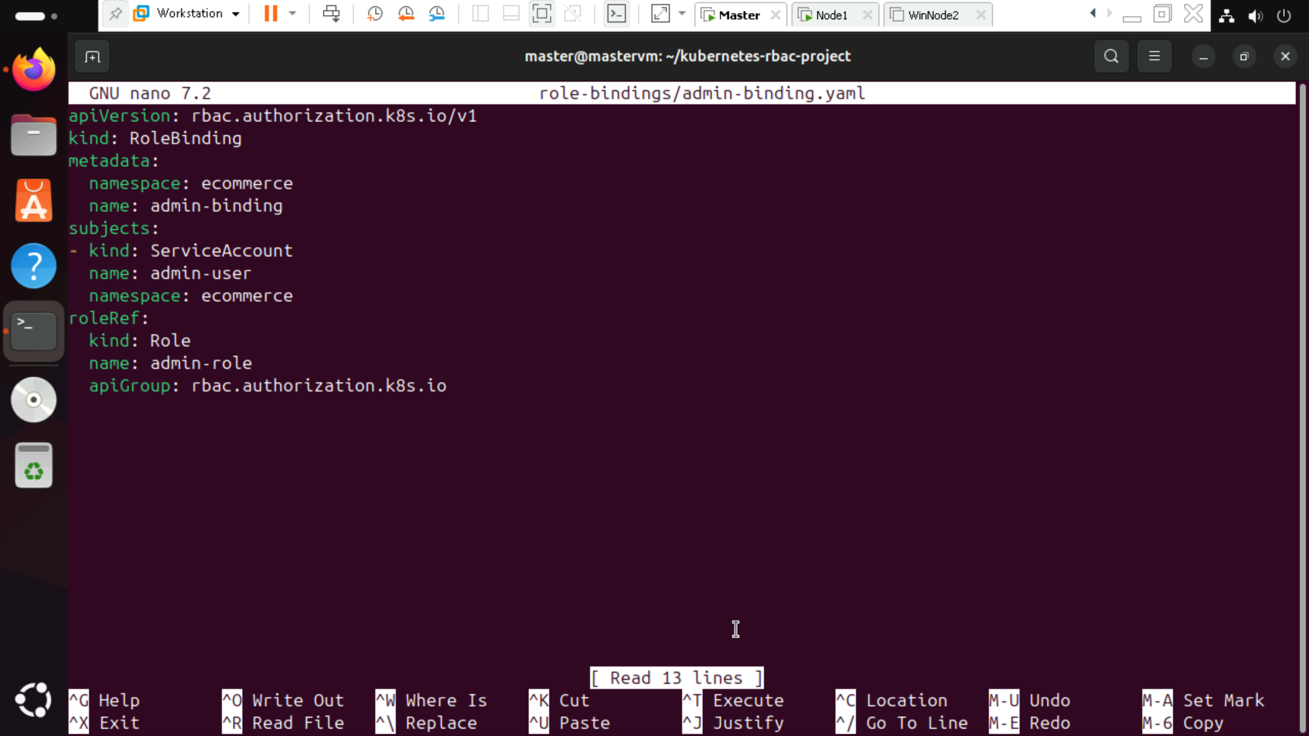

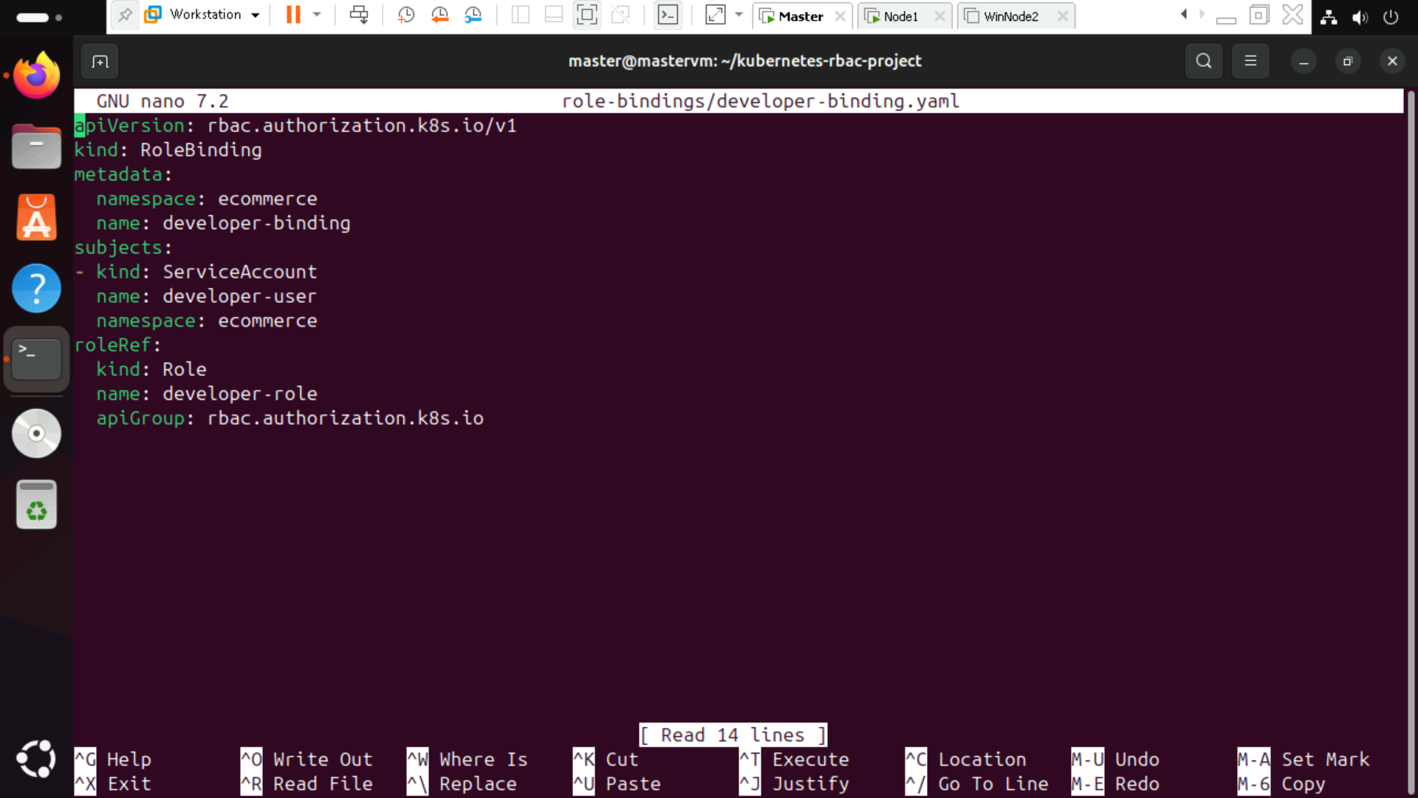

Step : Verify RBAC Permissions

Run the following commands to verify access:

Admin user can create pods:

kubectl auth can-i create pods --as=system:serviceaccount:ecommerce:admin-user -n ecommerce

Expected Output: yes

Developer user cannot delete pods:

kubectl auth can-i delete pods --as=system:serviceaccount:ecommerce:developer-user -n ecommerce

Expected Output: no

Developer user can list pods:

kubectl auth can-i list pods --as=system:serviceaccount:ecommerce:developer-user -n ecommerce

Expected Output: yes

Step : Test Pods Creation and Deletion

Admin can create a pod

kubectl run nginx --image=nginx --restart=Never -n ecommerce --as=system:serviceaccount:ecommerce:admin-user

Developer cannot create a pod

kubectl run nginx --image=nginx --restart=Never -n ecommerce --as=system:serviceaccount:ecommerce:developer-user

Expected Output:

Error from server (Forbidden): pods is forbidden